

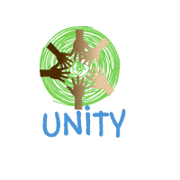 (Anae, 2015)(202 Cartoon Indian Graphics, 2010-2018)(Pinterest, Kāhore he rā)

UNITY - Learn a language mobile app Proposal

Hot topic in software 2018

Table of Contents

**1.Introduction** 3

1.2 Measurable Organisational Value (MOV) 4

1.3 Aim/Objectives 5

1.4 Research Question 5

**2. Literature Review** 5

2.1 Māori Language Learning App - Ashok Sugathon 5

2.2 Learn Samoan - AI Lab 5

2.3 He aha tēnei? - Pāpapa 5

2.4 Kura - Victoria University’s Faculty of Education 5

2.5 Simply Learn Hindi- Simya Solutions Ltd 5

2.6 Learn spoken Hindi from English- Devi Studios 5

2.7 Beginner Samoan - Shotgun.experiments **Error! Bookmark not defined.**

2.8 English To Samoan Dictionary - Appostorsystech 5

2.9 Memrise Learn a new Language - Memrise LTD 5

2.10 English Samoan Translator - Languages Translator 5

2.11 Learn Hindi Free WordPower - Innovative Language Learning 5

2.12 Learn Hindi Free Conversation Course - Ati Sudios 5

2.13 Comparison Table 5

2.14 Discussion 5

2.15 Literature Review summary 5

**3. Requirement Collection and Analysis** 5

**4. Methodology** 5

**5. Design and Analysis** 5

**6. Implementation and Testing** 5

**7. Reference List** 5

**8. Appendix** 5

**9. Information** 5

# **1.Introduction**

Māori are the native Polynesian people of New Zealand. They landed in New Zealand from eastern Polynesia sometime before 1300 CE. Past several centuries in seclusion, the Māori established a distinctive culture with their own language. In New Zealand, Maori is the second official language (Māori culture, 2016). On the other hand, Samoans are the very primitive inhabitants of the Samoa Islands; the Island lies towards the northern side of New Zealand. However, preponderance of the Samoans has settled in other countries, predominantly in the United States, New Zealand and Australia (Anae, 2015). Ultimately, Indians are inhabitants of India, a country located in south Asia. “Indian” represents nationality, but not ethnicity or language. Although, several languages being spoken in India, Hindi is India’s official language (People:India, 2018).

The scope of this project is to raise awareness to people about the Maori, Samoan and Hindi language. This idea was established by considering an already existing app known as ‘Learn Maori’ developed by Seyed Reza Shahamiri. The basic concept is to enhance the already existing app by adding new features and languages to raise language awareness. The app will help individuals who do not know how to speak their own native language or individuals wanting to learn a new language. Accurate word pronunciation is the key to learning a language. One of our main goal is to add accurate word pronunciations and therefore we shall be going out to gather accurate data from the native speakers themselves. Moreover, we shall also validate all the words, sentences and audio files with the native speakers ensuring that we have got accurate data in our app since the app will be used as a learning platform. This process is very crucial in this project as inaccurate data in the app will mislead the users.

The current app only has three learning parts which are; Numbers, colors and family. Therefore, to enhance the app further we shall be complementing it with Animals, everyday used phrases, additional numbers, colors and family members. All the words in each category will have an exclusive sentence to comprehend the words even more clearly. The app shall incorporate 100 words in total which will have a sentence each. Furthermore, the app will comprise of icons, audio files and written translations (both in English and the chosen language). Overall, by enhancing this app it will help us reach a wider audience and prompt language learning. This app is entirely dedicated to the society seeking for an opportunity to enrich their knowledge.

In every project it is very important to structure, plan and control the development process of an Information system. Thus, in this project we shall be using the Agile software development methodology. This approach is flexible in terms of adapting to changes, as we are going to be reengineering the app, any design or code changes can be quickly altered. Moreover, due to limited time in developing this app, by using this approach we will be able to deliver the project within the given timeframe.

### 1.2 Measurable Organisational Value (MOV)

This proposal was compiled to capture a conception or a prospect for an existing app “Learn Maori”. Although there is no major issue or problem with the “Learn Maori” app we determined there is an opportunity available with the use of reengineering to reach a wider range of consumers to learn Maori, Hindi and Samoan by adding relatable activities or functionalities including developing the application to be made available on both Android and iOS platforms. By increasing additional functionalities, we will be increasing the added value to the existing app. This in turn will give us a measurable goal that as a team we expect at least 500 users by the end of the first year and 250 users sub sequentially every 3 to 6 months.

The desired MOV impact area of our project will be Customer, in particular citizens of New Zealand for instance including Social by revealing two major indigenous communities within New Zealand that are; Māori and Samoan also containing a high proportion of residents and citizens of New Zealand that are Hindi. In New Zealand today we are a melting pot of cultural ethnicities, our national language Te Reo Māori  is promoted near and far worldwide but according to the 2013 New Zealand census only ‘3.7 percent (148,395 people) speak the Māori language, with Samoan at 2.2 percent (86,303 people) and Hindi (replacing French as the fourth most common language in 2013 spoken in NZ) at 1.7 percent or 66,309 people including English that is the most common language spoken at 96.1 percent of people’ (Creative Commons Attribution 3.0 NZ, 2014). These statistics tells us that Māori, Samoan and Hindi are the top 3 non-English languages spoken in NZ currently today.

Having identified the diversity of cultures in New Zealand and realising that the youth are our long term frozen assets in New Zealand, we believe focusing on this age group is important thereby introducing new functionalities and features of this app to appeal more to this target group including maintaining the current users interest and satisfaction. Our youth today are speaking the languages that have long been instilled in them, but most are unable to write or read their language. This is a potential problem in that our national ‘mother tongue’ may in the future be lost without daily revival of vocabulary and practice.

### 1.3 Aim/Objectives

This is where our aim of the project is important, that is to enhance an existing mobile application to ensure learning Māori, Samoan and Hindi are made easier and effective for the user. Our objectives are as follows:

1. To add new user- friendly features to attract all age groups (especially our youth). With this objective we are going to achieve this by carefully selecting vocabulary, phrases and sentences that are relevant to our young New Zealander’s and worldwide users. Vocabulary that this targeted group can associate and identify with for everyday use or to help in forming additional sentences that they can use in everyday communicative situations.
2. To provide an option for Hindi and Samoan including the Māori language to reach a wider audience. In offering the additional two languages that are most commonly spoken in New Zealand it is agreed upon, that to achieve this objective we must verify that each and every word/s used is accurate with validated pronunciation by indigenous speakers of the three languages. To promote this within the app we have established that the images/icons must be undeniably identifiable to the user.
3. To conduct research in order to collect accurate pronunciation information. In order to achieve this objective, we need to implement a strategic plan to obtain pronunciation accuracy, this is feasible by interviewing 2 -3 indigenous speakers of the chosen languages and collecting the qualitative data.
4. Research different features/functionalities that could be added into the application.

Upon agreement as stakeholders and taking into account our potential stakeholders we have analysed a number of apps and compared them to each other including the existing app in order to accomplish this objective.

As we will be reengineering the “Learn Māori” app we believe that SDLC is most appropriate as we will be following the steps of Software Development Life Cycle to complete our tasks. The resources needed are the existing app we have developed independently, quality and validation assurance, language app research, discussion with colleagues and tutors. For ‘out of scope’ analysis we will be delivering on the apps quality, cost and handling of the app, it’s deliverance including consumer service and app costs.

### 1.4 Research Question

*Can we improve the quality of the Mobile App “Learn Maori” to reach a wider audience by implementing options for two more languages that are Hindi and Samoan including new functionalities?*

A viable question as a team to reengineer an existing app that is presently downloaded more than one thousand times with a rating of 4.0 from 11 users (Store, 2017) in the Google Play Store. Currently available on Android platform only and due to time constraints of our own, the “Learn a Language app” can be reinvented once again for further student assignments by developing it to be made available on the iOS mobile platform too. Currently with the given timeframe we will achieve this research question by following a strategic plan to add value and to see it through to completion.

# **2. Literature Review – feedback review need to change**

For this proposal, a Literature Review is an important aspect where research findings are presented. In the following we will explain our findings and comparisons from a search of language apps selected by our team of six from either the Google Play Store (Android) or Apple iTunes (iOS). Each team member has selected two chosen apps to ‘use’, study and analyse gaining insight into how each app works, the apps functionalities and features available to the consumer. Our intention with this review is to provide the ‘drive’ in research and to encourage further interest with our findings.

### 2.1 Māori Language Learning App - Ashok Sugathon

(Sugathan, 2015)

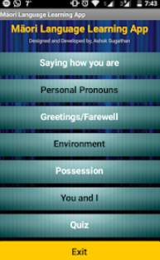The Maori Language Learning app is designed and developed by a student from Christchurch Polytechnic Institute of Technology. The developer states that the reason for developing this app is to “help the user learn Māori language” (Sugathan, 2015). There are four main features of the application that include a translation of words, a selection of quizzes, an interactive button that allows you to share with friends including ‘some words’with pronunciation. Upon entering the app there are seven clickable modules. The seven modules include a total number of 68 English words with the equivalent in Māori translation. Within the module ‘Environment’ there is audio for each word. This is the only module that provides audio where the pronunciation sounds like it is being spoken by a Non-Māori person. One third of the reviews in the Google Play Store are negative and one user even states “There’s not much point in trying to learn a language if you have no idea what it sounds like” (Sucks, 2017). Overall the app is quite basic including the look and feel that would not keep young children entertained as there are no visuals used anywhere. There is a need for interaction of design when comtemplating the look and feel of an app . Pre school and school age children for example, will not be able to identify with just words displayed in an app, visuals are more distinctive and easy to remember whereas words are vague or insubstantial and easily forgotten (Marcus, 2017).

Fig. 2.1a Māori Language Landing Page

(Sugathan, 2015)

### 2.2 Learn Samoan - AI Lab

(AI Lab, 2017)

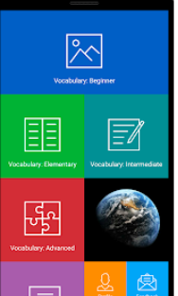Learn Samoan is a Samoan language app available online for free in the Google Play Store where you can learn bilingual Samoan through both English and Samoan learning. With a rating of 5.0 from just 3 reviews, it has one thousand downloads and is developed by AI Lab (Google Play Store, 2017). Upon accessing the app for the first time the design of the main menu is appealing. There are 7 main modules including 4 modules that pertain to the users profile and settings options. The functionalities start from ‘Vocabulary: Beginner’ through to stages to reach Advanced.

These stages each contain 30 numbered adjectivess, verbs, phrases and so on. This immediately tells me that the app contains a vast library of data. Selecting the first module and going through each word on the list takes you to another list of English Words with the translation in Samoan and vice versa. The lists are downloadable on selection with no visual or audio interaction at all in any module. I surmise, as previously stated that by neglecting to add visual and auditory stimulation there is no appeal for children under the age of 13.

Fig. 2.2a Learn Samoan Landing Page

(AI Lab, 2017)

### 2.3 He aha tēnei? – Pāpapa

(Squarespace, 2017)

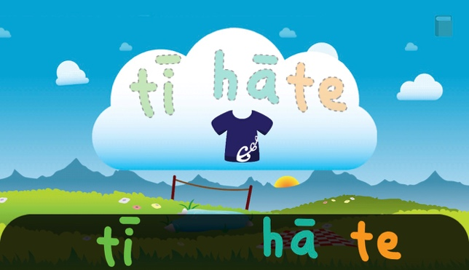He aha tēnei is a little game app where you can drag and drop matching letters and once the letters are matched you can hear a pronunciation of the word (App store preview, 2018). For example, once you drag and drop the characters of the word ‘maika’ (banana) you can thereafter hear it pronounced. You have to ensure you complete the word to hear its pronunciation. This app was specifically built to foster the special language connection amid kids and their caregivers (Squarespace, 2017). This application is available both on iOS and Android platforms. It includes around every day 19 words with background music. However, it lacks everyday words like good morning, please, help etc. which are vital in the language learning process. Moreover, the words aren’t displayed in English which brings in the confusion for the real Maori meaning. For instance, a picture of a clock can have two meaning, clock or time. Therefore, having an English word accompanied with the translation could make it much clearer (Google play, 2018). The app has got a rating of 4.8/5. However, it has limited words and lacks English translation to the wordings. As a result, studying the user reviews it reveals that after using the app for a certain period of time users lose interest as the app only accommodates 19 words.

Figure 2.3 a: He aha tēnei (App Store Preview, 2018)

### 2.4 Kura - Victoria University’s Faculty of Education

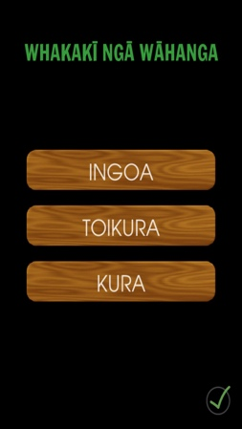

This Maori language application comprise of five different games. The first game is known as ‘Puna kupu’ which supports its users by increasing their vocabulary. It enables you to hear the correct pronunciation and identify the names of images used right through the game. The second game is known as ‘E Rua, e Rua’ which is a time limit game where you have to use your understanding from the vocabulary practice to accurately match the word to its image. The third game ‘Ihumanea’ aims at expanding your knowledge by offering various sentence structures through multi-choice questions. The fourth game ‘Tohu Kupu’ uses your understanding from the game ‘Ihumanea’ to accurately form a Maori sentence. Finally, in the fifth game ‘Kīkiki Pāoro’ you have to answer general questions of New Zealand by kicking the rugby ball over the appropriate goal post (App store preview, 2018).

Figure 2.4a: Kura (App Store Preview, 2018)

The app consists of great features however its major drawback is that everything is in the Maori language, which makes anyone unfamiliar with Maori language using the app stop at the home page. The main purpose of the app is neglected. Moreover, the images and their translations provided are confusing to whether what the actual meaning is, as there is no English translation to it. The app got a rating of 1.0/5 and looking at the user reviews it discloses that many users couldn’t access the app as it kept on crashing and couldn’t load the app due to memory issues. Moreover, to use the app you must be connected to the internet. Overall, the app has got some good content however lacks the major features for learning Maori.

### 2.5 Simply Learn Hindi- Simya Solutions Ltd

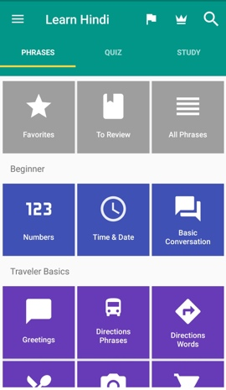It is a Mobile Application developed on Android and iOS platform which enables a user to learn the Hindi language. The home screen provides you three fundamental categories which are Phrase, Quiz and Study. Phrase category is having a list of phrases. Quiz gives the user a set of questions with multiple answer options and at each question, the user will notify whether the answer is correct or wrong. The study category provides the questions without answer options, but the user can use limited flashcards to avail the answer (Simya Solutions Ltd., 2018).

Each of the three categories are having four section which are namely Beginner, Travel Basics, Travel Advanced, Expat. Out of these four sections, The Beginner and The Travel Basics are available for free, while to access the other two, one needs to upgrade to pro with onetime payment of $11.99. Upgrading gives you benefits of thousand plus phrases and words, lifetime access to all quizzes, smart flashcards to adjust the learning process and ad-free interaction.

Fig. 2.5a Simply Learn Hindi Landing page

(Simya Solutions Ltd., 2018)

Beginner section provides various categories like Numbers, Time & Date, Basic conversation. Traveler Basics section includes Greetings, Direction Phrases, Directions Words, Eating Out, Sightseeing, Shopping, Emergency, Accommodation. Traveler Advanced section includes categories which are; Advanced Conversation, Health, Border Crossing, Questions, Places, Food, Vegetables, Fruit, Colors. The last Section which is Expat provides categories which are Romance, Romance 2, Post Office, Phone & Internet, Banking, Occupations, Business Talk, Hobbies, Feelings, Body, Animals, Family, Countries. Including all the above it gives you the easy access option for favorites in which you can add any phrases available in the application. Apart from that, it gives you login functionality using Facebook, an option to track your progress, variable speed of audio, Learning reminder and various language option for language in Application and Quiz.

Simply Learn Hindi application is having overall 4.6 rating out of 5 and 682 reviews. It can be useful to people who are traveling to India from all over the world and who do not know the Hindi language also. It is available for free on the Android Play Store.

### 2.6 Learn spoken Hindi from English- Devi Studios

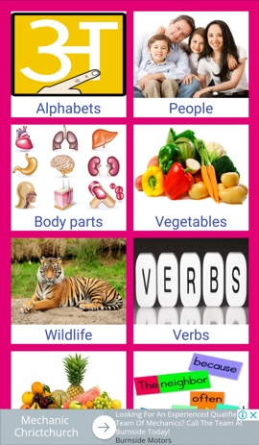This application helps users to easily learn spoken Hindi from English. Use of Hindi words and sentences along with English meaning which helps in learning easily. The images and colors are provided for easy understanding and for an aesthetic interface. Audio files which were used in the application is sharp and clear enough, which is very useful for the users who find it hard to pronounce the Hindi language. Design and interface are easy and attractive for the pleasant experience (Devi Studios, 2017).

The home screen gives users a list of categories along with picture and category name in English. The list includes Alphabets, People, Body Parts, Vegetables, Wildlife, Verbs, Fruits, Sentences, Numbers, Colors, Adjectives, Prepositions, Pronouns, More Words. Most of these categories give Hindi words or phrases or sentences along with picture phonetic name, English meaning and a play button to play the audio.

Fig. 2.6a Learn Spoken Hindi Landing page

(Devi Studios, 2017)

The game is developed on Android platform by Devi Studios and it is having an overall rating of 4.3 out of 5 which is rated based on 104 different reviews by users. The application is very useful for the people who are having zero knowledge of Hindi and want to commence learning.

### 2.7 Beginner Samoan - Shotgun.experiments

(shotgun.experiments, 2017)

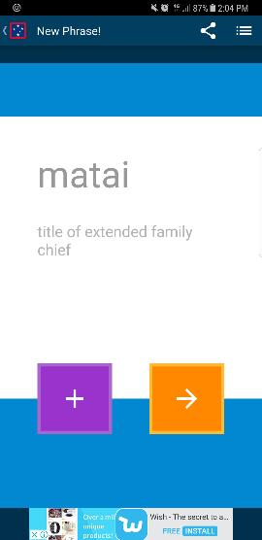Beginner Samoan is a mobile app designed to teach basic Samoan Language in an interactive approach to get the user’s attention by utilizing a quiz to test the knowledge of the user and earn rewards. The scope of the application is targeted for beginners and those interested in learning a new language (shotgun.experiments, 2017). The app has 6 functionalities that include a Quiz, Favourites, Hide/Reveal, Google (to access the Play Store), Share, Plus one function including 6 pages to toggle back and forth, that I assume will fill up as you keep adding words to your list.

A couple of ‘Pros’ are that it is; simple in design and the fonts are clear. The ‘Cons’ outweigh the ‘Pros’ such as, grammatical errors (quotations marks are incorrect, lack of accents for pronunciation purposes), no audio which is very important in learning the Samoan language as audio will help to get the correct pronunciation, limitation of learning 12 words daily, no word search option and the ‘Look and Feel’ of the app is poor. The app is only available on Android 4.0.3 and higher and it is currently not available on iOS. Developed by shotgun.experiments. It has gained a rating of 4.1 received by 14 user reviews. Installs or downloads range between 1,000-5,000. The targeted age group is 3+.

Fig. 2.7a Beginner Samoan Landing Page

(shotgun.experiments, 2017)

### A screenshot of a cell phone Description generated with very high confidence2.8 English To Samoan Dictionary – Appostorsystech

(Appstorsystech, 2016)

A screenshot of a cell phone

Description generated with very high confidenceEnglish To Samoan Dictionary is a mobile app that translates more than 75,000 (Appstorsystech, 2016) English words to the Samoan translation. It consists of two activity pages. The initial page has a list of words in alphabetical order, starting with A. A search box at the top of the list, which automatically searches as you type each letter. It has a scroll page feature, which allows the user to scroll up and down the list of words. When a word is selected from the list, it directs you to another activity page, which completes the app. The page is dedicated to the selected English word and has the Samoan translation beneath.

Fig. 2.8a English to Samoan Dictionary Landing Page

(Appstorsystech, 2016)

There is audio for both the English and Samoan word, other features include a copy icon, the use of the android device back button, a 'Rate Us' icon which directs you to the Google Play Store when selected, a 'Share App' icon that, gives you the options of which other app to share the app on e.g. Email and a 'Like Us' icon, which increments the number of likes the app receives. Very simple in design, I like the fact that you can search any word and there is no limit to how many words you can search. It provides almost an accurate translation of every English word. However, the pronunciation of the Samoan words is incorrect. They need recordings of someone who can speak the language fluently to pronounce the words correctly. It has a rating of 4.3 received by 91 reviews.

### 2.9 Memrise Learn a new Language - Memrise LTD

Learn another Language, is an educational app found in the Google Play Store (Play, n.d.) and iTunes (Apple, n.d.). it’s a top grossing application which, to begin with, is free, you can learn 5 words each day per language. The app contains a large variety of languages such as Norwegian, Japanese, Korean, Spanish and Dutch in total there are twenty-two different language courses you can participate in. (memrise, 2018) The premise of the application is that you’re a spy sent off to a distant universe to be successful you need to learn various languages on your journey.

The game starts with a story like setting and then sends the user to the selected course for their chosen language the app tests users with sound audio and written text to help users memorise the words that they are learning. To unlock the full experience it’s an annual subscription of $37.50 (your first year is 50% off) (memrise, 2018) you have other payment options, a month is $11.46 and three months is $23.00 (memrise, 2018) this application has received the Editor’s Choice award along with the Google Play I/O Award for best app in 2017 the level up system is based on a score you obtain during courses conditions for this is accuracy and timed this adds a fun element to learning the language it offers a competitive nature to obtain really good scores for each course taken.

### 2.10 English Samoan Translator - Languages Translator

English – Samoan Translator is a translator application in which you type a sentence in English or Samoan and it will translate and pronounce whatever you have typed after using the application for a while I discovered that it wasn’t pronouncing words correctly between the languages it wasn’t very accurate when translating back to English ether the pros of the application would be the ability to type sentences in ether language and have them translated to the other, the design is very simple and easy to navigate upon my first interactions with the application However there are cons to the application as well the colour scheme is very bland and hard to look at for durations of time and the words aren’t accurately translated back to English and some English to Samoan translations were also inaccurate. While the app is without its faults it has given me some insight on possible design choices we could utilise for our Language application. Available only on Google Play (Play, n.d.)

### 2.11 Learn Hindi Free WordPower - Innovative Language Learning

This iOS compatible app is the great example of learning a language using flash cards. The Flash Cards aid in memorising a certain word which is easy and fast. The developer of the app - Innovative Language Learning USA LLC has developed many more learning languages apps (App Store, 2018). This app has many features that helps in learning Hindi. The Home page of the app has different options to learn from. You can either select to learn through a Study Course or you can learn from basic categories. The Study course gives you option to learn Hindi words according to you experience. It starts with the Basic Vocabulary part 1 i.e. Level 1 and goes up to Lower Intermediate Part 2 I.e. Level 10. Unfortunately, the level 2 onwards can be accessed in the after you purchase the app from the app store. For the free subscription of the app you may access the Top 100 Indian words and the level 1 of the course. The Second option from the home page is to learn Hindi by choosing categories of the words e.g. Food, Drinks, Places etc. All the categories include the Flashcard feature which can give you all the words in the category at once. Each category in the study category section as well as the study course section has the learning bar that tell you the completion of the learning, that increases only once you have clicked on the word and learnt the pronunciation along with the sentence. Or it will grow up if you use the flashcard and go through all the words. The app is not interactive, the Flashcards do not come with images, visuals are not too appealing, and you must buy the full version of the app to progress further in your learning.

### 2.12 Learn Hindi Free Conversation Course - Ati Sudios

Mondly is the track recording tutorial-based learning app. It gives the learner an opportunity to learn by doing. This interactive app encourages you to first learn through lessons and then provides quizzes for you to solve and make yourself an expert. The audio and visuals of this app are superb. Fun lessons help you revise vocabulary, grammar and pronunciation with proper guidance and great learning methods (App Store, 2018). After completing every quiz, you will be rewarded with points that will encourage you to learn more. After four categories of learning, the app will prompt you to pay to earn more. The Home page is the map that you need to track for completing your exercise. The map tracks forward once you complete all the lessons in each milestone. Each milestone has the features of learning through lesson, conversation and vocabulary. The interactive design of the app makes the user feel more comfortable in learning by practicing. There are many Pros within this app that include; fun and interactive learning, rewards for correct answers, ‘Look and Feel’ is professional. The only con is that further lessons of the app become accessible only after you pay for subscription.

### 2.13 Comparison Table

Language Learning App Comparison Table

|  |  |  |  |  |  |  |  |  |  |  |  |  |
| --- | --- | --- | --- | --- | --- | --- | --- | --- | --- | --- | --- | --- |
| No. of apps | **1** | **2** | **3** | **4** | **5** | **6** | **7** | **8** | **9** | **10** | **11** | **12** |
| Application Name | Simply Learn Hindi | Learn Spoken Hindi From English | Māori  Language Learning App | Learn  Samoan | He aha tenei | Kura | Beginner Samoan | Memrise:Learn a new Language | English to Samoan Dictionary | Learn Hindi- Free WordPower | Mondly: Learn Hindi FREE - Conversation Course | English Samoan Translator |
| Developed by | Simya Solutions | Devi Studios | Ashok  Sugathan | AI Lab | AIgomythms limited | Victoria university’s faculty of education | shotgun.experiments | Memrise LTD | Appstorsystech | Innovative Language Learning USA LLC | ATi Studios A.P.P.S. SRL | Languages  Translator |
| Target Age Group | 4+ | 4+ | 4+ | 4+ | 4+ | 4+ | 3+ | 3+ | 3+ | 4+ | 4+ | 4+ |
| Rating (1-5) | 4.6 | 4.3 | 3.4 | 5.0 | 4.8 | 1.0 | 4.1 | 4.7 | 4.3 | 3.4 | 5.0 | 3.5 |
| No. of Reviews | 682 | 104 | 36 | 3 | 145 | 21 | 14 | 999,473 | 91 | 3 | 3 | 14 |
| Google Play Store | Yes | Yes | Yes | Yes | Yes | Yes | Yes | Yes | Yes | No | No | Yes |
| Apple iTunes | Yes | No | No | Yes | Yes | Yes | No | Yes | No | Yes | Yes | Yes |
| Video? | No | No | No | No | No | No | No | No | No | No | No | No |
| Image? | No | Yes | No | No | Yes | Yes | Yes | Yes | No | Yes | Yes | No |
| Audio? | Yes | Yes | No | No | Yes | Yes | No | Yes | Yes | Yes | Yes | Yes |
| Sentences? | Yes | Yes | Yes | Yes | No | No | Yes | Yes | No | Yes | Yes | Yes |
| Questions? | Yes | Yes | Yes | Yes | No | No | Yes | Yes | No | No | Yes | Yes |
| Language | Hindi | Hindi | Maori | Samoan | Maori | Maori | Samoan | Wide range | Samoan | Hindi | Hindi | Samoan |
| No. Downloads  (Approx.) | 50,000 | 10,000 | 10,000+ | 500 | 10,000 - 50,000 | 10,000 - 50,000 | 1,000 - 5,000 | 10 million | 10,000 -50,000 | NA | NA | 1,000 |
| Reference |  |  |  |  |  |  |  |  |  |  |  |  |

*Table 1*

### 2.14 Discussion

By reviewing twelve language apps from both mobile platforms we produced a comparison table (Table 1) that identifies the most common functionalities of Mobile Language apps today. From this analysis we observed the ‘Memrise’ app available on both mobile platforms is the most widely known and used language app with a 4.7 rating from close to one hundred thousand reviews and winner of two recognised awards. The ‘wow factor’ of this app is apparent in satisfying users interest and willingness to learn and is the only app reviewed by our team that has more than several languages available to learn in one app. This indicates that apps of this magnitude are perhaps more versatile for the consumers’ needs rather than a single language learning app. ﻿

The reason behind choosing the two Hindi Learning applications for the review is that they are having good ratings in the play store. Also, the design used in the Simply Learn Hindi is very creative and beautiful. The categories used in the application are quite helpful for a large age group. However, the few categories are not accessible for free. The other application Learn Spoken Hindi from English made use of the clear images very well along with the colorful designs which will help in easy understanding, but the female audio used in the application is fast and not clear enough.

The targeted age group in all the apps reviewed is either 3+ or 4+ demonstrating the average age group the developers are wanting consumers to start using their app are preschool children, yet 4/11 apps do not have visual aids and 3/11 apps do not include audio which is imperative for cognitive development and essential for learning in this targeted age group. Across the board there are no videos used within these language learning apps that is indicative of a possible need for this function to aid in language learning or could possibly mean the consumer has no need or patience to watch a visual aid that is lengthy.

After carefully reviewing all the apps, we feel it is very important for a language learning app to have accurate word pronunciations (audio recording of someone who can fluently pronounce the word accurately), images or icons to support understand the words better, written translations both in English and the selected language. We also found the need to complement a word with a simple sentence to help the users understand the word even more clearly. Examining the above apps, it is clear that high portion of the apps are missing these important functionalities. Therefore, we feel it is compulsory to have the above functionalities in any language learning app. It is very important to adopt these functionalities as Firstly, people want to learn how every word is actually pronounced and therefore we need audio supported in the application making sure each and every word is accurately pronounced with the appropriate accent. Secondly, it vital for apps to be supported by visual images to help users clearly understand the words and also bring in the atmosphere of professional learning. Thirdly, it is extremely critical to accompany each word with an English translation, many users quit using the apps within a very short period of time since they cannot clearly understand what they are learning and end up uninstalling the app. Therefore, having an English translation in the app is essential. Finally, the look and feel of any application is very important, by carefully selecting the theme and design of the app we can make it fun and interactive.

Maori, Samoan and Hindi being one of the top spoken languages in New Zealand, we found the need to add Samoan and Hindi language in the already existing app. Moreover, we are looking forward to redesigning the current application so that we can incorporate the addition features being added to the app. We shall be adding additional family members, colors and numbers. We will also include Animals and everyday phrases. Each word will be accompanied by a simple sentence, which will have a pronunciation of its own. We shall also be including transitions and animations to make the application more appealing. To see the basic design of the app please refer to the design section below. Overall, we will be including all the features mentioned above which are missing in most of the language learning apps studied earlier.

### 

### 2.15 Literature Review summary

|  |  |  |
| --- | --- | --- |
| Name of App | Pros | Cons |
| Māori Language Learning App  **Invalid source specified.** | 1. Consists of 7 learning modules | 1. Inaccurate word pronunciation (done by non-Maori speaker) 2. No point of learning a language when you do not know how it sounds like. 3. No use of visual 4. Not suitable for preschool and school age children, lacks visuals |
| He aha tēnei?  (App store preview, 2018) | 1. Interactive game for children 2. Good use of visuals | 1. No English translations 2. Only contains 19 words, chances of losing interest after certain period of time 3. Lacks everyday words that are vital in the language learning process. |
| Kura  (App store preview, 2018) | 1. Comprises of 5 different games 2. Has got quite few vocabularies. | 1. Whole app is designed in Maori, no English translations 2. Users get stuck on the landing page, as everything is written in the Maori language, making it difficult to navigate through the app. 3. Memory issues making it difficult to load the app 4. Must be connected to the internet |
| Simply learn Hindi  (Simya Solutions Ltd., 2018) | 1. Comprises of copious vocabulary 2. Login using Facebook to track progress | 1. To access additional learning materials, you have to make a one-time payment 2. Disrupting ads |
| Learn spoken Hindi from English  (Devi Studios, 2017) | 1. Interactive visual flairs 2. Consists of copious vocabulary 3. Suitable for all age groups | 1. Annoying ads 2. Female audio used in the application is fast and not clear enough. |
| Beginner Samoan  (shotgun.experiments, 2017) | 1. Simple in design 2. Fonts are clear | 1. Grammatical errors (lack of accents for pronunciation purposes) 2. No pronunciation audios 3. Limited to learning 12 words daily 4. Poor app look and feel |
| Learn Samoan  (Google Play Store, 2017) | 1. Main menu is appealing 2. Vast library of data | 1. No visual or audio interaction throughout the app 2. No appeal for children under the age of 13 3. Fails to keep current users interested as the app doesn’t have visual or audio interactions. |
| English To Samoan Dictionary  (Appstorsystech, 2016) | 1. Translates more than 75,000 words | 1. Inaccurate pronunciation of the Samoan words 2. Requires recordings of someone who can speak the language fluently to pronounce the words accurately. |
| Memrise  (memrise, 2018) | 1. Supports variety of languages 2. Support audio and provides written translation | 1. Need to pay annual subscription fees for full experience |
| Mondly: Learn Hindi FREE  (App Store, 2018) | 1. Fun and interactive learning app. 2. Motivates you to learn more by rewarding you with points after each correct answer. 3. Graphic User Interface is very beautiful and has the vibe of professional learning. | 1. The further lessons of the app become accessible only after you pay for subscription. |
| Learn Hindi- Free WordPower  (App Store, 2018) | 1. You get to learn using flash cards which is fast and easy. 2. You can learn the use of the words in sentences. 3. It gives you word of the day notification to make you learn a new word each day. | 1. Flashcards don’t come with images and to learn the word in sentence you have to click and get navigated to the sentence page. 2. The user has to click at least five times to go to the learning page of the word. 3. The visuals are also not much attractive. 4. The app is not interactive, the user has to just see, hear and learn. 5. For more learning you need to buy the full version of the app. |

*Table 2 Literature Review Summary Table*

# **3. Requirement Collection and Analysis**

The main implementation of our project is to re-engineer a legacy system i.e. 'Learn Maori', a mobile app for android, created by Dr. xyz, to include more categories that are not available on the legacy system. The project initially started with just the Maori language. Our lecturer then suggested that we add the Samoan and Hindi languages which will be an added value. As per the national census, discovered by our team leader Aaaaa, it is surveyed that besides English, Maori, Samoan and Hindi are the top most spoken languages in Aotearoa (New Zealand). We reviewed twelve existing systems (mobile applications) and review their functionalities. From collecting information on the functionalities of each existing system, we identified their pros and cons and from here, we can make comparisons with our project. The team brainstormed on the categories that we will include in this ‘Learn a new language’ mobile application for android.

As we are re-engineering a legacy system or an existing mobile application i.e. ‘Learn Maori’. It currently has four categories i.e. Practice Waiata (Traditional Maori songs), Numbers, Colours and Family members. Our added value, is to include two other categories i.e. Animals and Phrases. In the proposed mobile app, we will not include the ‘Practice Waiata’ category because we want the mobile app to focus on the more consistent use of the languages. As a group we discussed what parts each member will focus on. We were each given a category i.e. Kanika - Family category, Ccccc – Numbers category, Bbbbb – Animals category, Aaaaa – Colours category, myself (Bbbbb) – Phrases category and Connor was appointed to do the design of the mobile application. Each member that was appointed a category, were given the task to list 30 words and find their translations in Maori, Samoan and Hindi languages.

For my appointed category, first, I listed down every day phrases in the English language and then wrote down their translations. For the Samoan translation, I did it myself, as I am a native Samoan and I speak the language fluently. The Maori and Hindi translation, I obtained from Google Translate.

Ccccc and Kanika worked on collecting the Hindi translations for “Family Names” and “Numbers”, and on validating the Hindi translation done by other team members for rest of the categories. We did use google translator for writing the Hindi fonts and Hindi learning websites, video tutorials to validate the translations and generating the sentences. Ccccc used “soundoftext” tool which is available online to generate the audio files for all the Hindi translations and sentences for each category. They used Google Translate to obtain translations for Maori and Samoan.

Bbbbb used the Maori dictionary, an application service available online and mobile called, wordHippo and google translate to obtain translations for her category.

Aaaaa also researched the Maori dictionary, a website called “Te Kupu o te Wiki” for reference and audio aid. Google translation was abundantly used for translating from English to Maori, Samoan and Hindi, while the team collectively collaborated to correct any incorrect translations. Aaaaa also stated that to create the sentences she used ideas from children’s books and store-bought story books that she has read to her children over the years.

# **4. Methodology**

Software development methodology is a collection of details which are used to structure, plan and manage the process of software development. Software Development Methodology is critical since it decides all fixings that prompt fall flat/achievement, in a product venture. As we are improving and adding the new functionalities in the existing application we are going to use the re-engineering approach with agile development methodology. The re-engineering re-utilizes things as of now in the old programming to keep away from misuse of material and otherworldly diminish upkeep costs take to realize the financial esteem, the best.

The development of costs and the significance of programming organizations, offices, little and medium endeavors and expansive associations were compelled to endeavor reengineering programming. Fundamentally, the product re-designing is to take and pass the current software. It is the product upkeep costs, repair costly or framework engineering and execution have neglected to do. We take it with innovative programming and hardware usable. Be that as it may, the trouble here lies in understanding the present framework. Normally the necessities, plan and report source (code) isn't accessible or has lapsed long back so it's not clear. So, the question here is what functions to move? Normally the framework will incorporate features not required; it should be evacuated in the new software framework (Robert Diana, 2010).

The procedure includes separating each undertaking into organized necessities and delivering each section inside an iterative cycle. A cycle is a routine of growing little segments of an undertaking at any given moment. Every emphasis is looked into and evaluated by the improvement group and customer. The bits of knowledge picked up from the appraisal are utilized to decide the subsequent stage being developed. If there are any clients associated with the project they will come to prescheduled consistent gatherings to audit the work finished the past emphasis, and to design work for the forthcoming cycle. Nitty gritty objectives are set in every emphasis meeting, for example, expected modifications, time appraisals, needs, and spending plans (N.A., 2013).

With the increment in the utilization of advanced mobile phones, the market for versatile application improvement develops quickly. It turns into a testing errand to build up an application having a long-life expectancy. Subsequently, important for application developers to embrace the always showing signs of change showcase pattern to pick up the positive results. So Agile methodology is the efficient choice for mobile application development which will help in faster development especially when it is critical. Agile methodology provides a different approach from other methodologies. Another reason is Agile has an ability to shift quickly and easily and is able to cope with changes which is an important perspective of Agile development methodology (Mehul Rajput, 2017). It also provides more flexibility compared to other methodologies. As per Agile development process, we are going to break our development into phases. The important phases of the development lifecycle are as follows:

1. The concept phase (Pre-Planning)

* 1. Defining the business opportunities in the current market.
  2. Determining the feasibility.

2. Inception: Project Initialization

* 1. Building the team.
  2. Modeling for the application.
  3. Setting up the work location and preference.
  4. Estimating the application.

3. Construction iterations

* 1. Requirement collection.
  2. Prioritize the requirements.
  3. Implementing the selected functionality.
  4. Analyzing and designing.
  5. Quality check.
  6. Consistently delivering working solutions.
  7. Parallel Testing.

4. Transition

* 1. Final testing of the application.
  2. Modification.
  3. Finalization of documentation.
  4. Deployment of the application.

Please refer to Appendix 1: Gantt chart for more details on the list of tasks and time frame.

As we are developing an android application we are going to use the Android open development platform. Front-end coding is going to be done in XML and for back-end coding, we are using Java which is the most popular option when it comes to developing an Android application. In fact, Java is considered as the conclusive language for Android application development and it is having more support of Google compared to other languages (Sinicki A, 2017).

# **5. Design and Analysis**

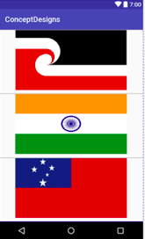

*Figure 5a Screenshot of Main Activity/Landing Page*

As a team we discussed many designs but decided to best represent the main page of our application, that it would be best for the user to choose their desired language as the first step after opening our application the user may select one of three flags which will then proceed to the main page that contains the categories the user can choose from to learn (as seen below in figure 2). The reason we decided to design our landing page around a flag image is because it best represents the language the user wishes to learn, it relates to cultural identity and it helps new users to identify the country flag related to the language selected. An example of this is the New Zealand’s Maori Community whom have their own flag to represent their culture; however New Zealand’s flag is different to the Maori flag. This is a rough outline of how we want to design the main page however it is still subject to change as we find new ways to make it more pleasing to the eye.

We aim to keep our app simple and easy to navigate as our target age group is 4+ thus making it easier for young children to navigate and learn while also keeping it appealing for current users to pick up the app and enjoy learning a new language and to captivate others to learn about our diverse cultures. Figure 2 represents a rough design of what the user will see after selecting the chosen flag or language of choice.

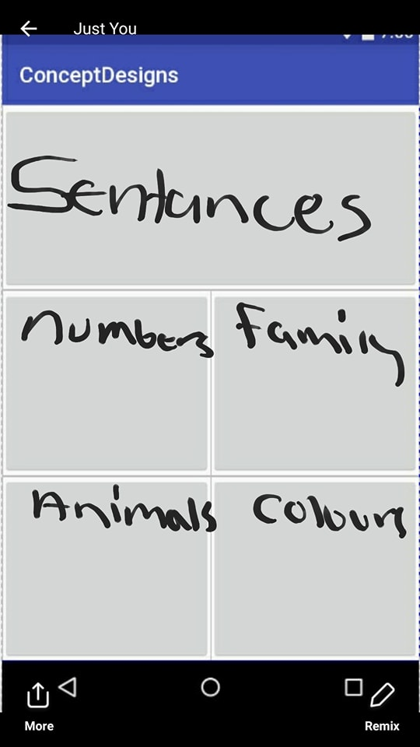

(Phrases)

(Numbers, Family)

(Animals, Colours)

*Figure 5b Screenshot of Concept Design*

Here we have a rough design of the next page (Figure 3) activated by the user after the main /home screen where the user can select a category which will then direct them to the activity that contains all the English to Language chosen translations. The translations will be structured in a list view format because we agreed as a group that it is very simple and easy to navigate and learn. (an example of the list is provided in Figure 3 and 4)

In the list view examples below I have demonstrated what the list view could look like in appearance with basic icon attributes with the word and a play button for our Numbers Activity. I have also provided a raw look at the structure of the list to give context, however I am planning to design the list to provide the English word, Samoan, Maori and Hindi translation side by side in the final list view.

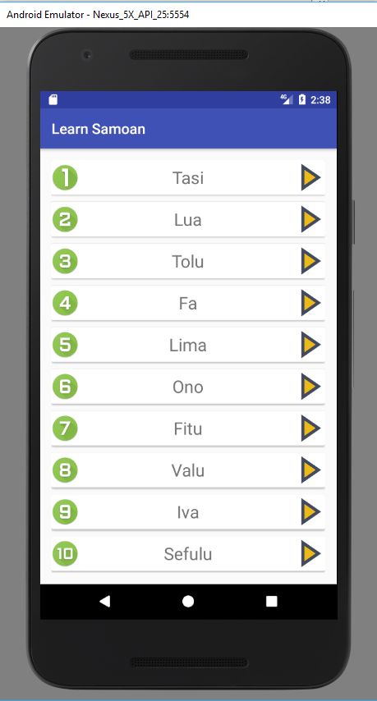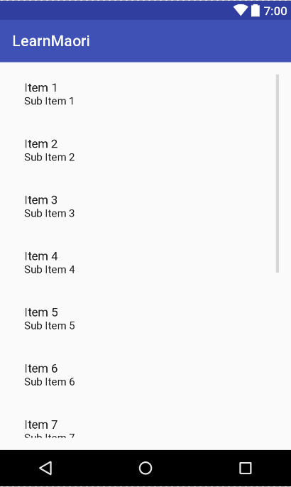

*Figure 5c Screenshot list view example**Figure 5d*

# **6. Risks**

Risk management implies chance to control and alleviation. In the first place, you must recognize and plan. At that point, be prepared to act when a risk emerges, drawing upon the experience and information of the whole group to limit the effect to the software (B.W. Boehm, 1991).

*Table 3 Risk Management Table*

|  |  |  |  |
| --- | --- | --- | --- |
| **RISKS** | **DESCRIPTION** | **RISK LEVEL** | **MEASURES** |
| Application size constraint | Use of large number of audio files can increase the application size. | Minor | Use of compressed audio files considering the quality of audio.    Code reuse. |
| Use of dissimilar words | Use of different meanings for word while translating into another language, as there can be more than one meaning of a word. | Minor | Validating the content using more than one dictionaries.    Utilizing knowledge of native speakers. |
| False knowledge | Any mistake in translation or pronunciation can lead to giving false knowledge. | Minor | Validating the content using different sources. |
| Use of native person to validate the content | Person might go wrong on validating the translations and pronunciations which can leads to false knowledge. | Minor | Use of more than one native speaker. |
| Team management | Managing large team with different skill set and assigning tasks. | Major | Proper use of software development methodology chosen.  Regular meetings and discussion on regular work deliverables.  Proper communication and work friendly environment.  Understanding the skills of each team member and assigning the task based on the skills acquired by them. |

As *Table 3* above shows these are some of the risks that can occur during the development of our mobile application. It also includes the description of the possible risks, the impact level and the measures to be taken to avoid those risks.

Risk administration is an adjust of hazard and reward, in this manner, it is fundamental that—as the group surveys the requirements and should likewise assess the risk for every requirement. In programming, a high risk regularly does not relate to big benefits. Rather, the driving inquiry for overseeing danger ought to be: Does the desired benefits for every requirement the level of hazard that the developers are expecting as it continues with advancement? By thinking about other choices, the team can accomplish an equivalent level of reward without about from many risks (n.a., n.a.).

# **7. Implementation and Testing**

# **8. Reference List**

(2018). Retrieved from Google play: https://play.google.com/store/apps/details?id=nz.co.papapa.heahatenei&hl=en

*202 Cartoon Indian Graphics*. (2010-2018). Retrieved March 2018, from Cartoon Indian vectors and photos - free graphic resources: https://www.freepik.com/free-photos-vectors/cartoon-indian

AI Lab. (2017, December 5). Learn Samoan.

Anae, M. M. (2015, March 25). *Samoans - History and migration*. Retrieved from Te Ara - the Encyclopedia of New Zealand: https://teara.govt.nz/en/samoans/page-1

*App store preview*. (2018). Retrieved from Apple: https://itunes.apple.com/nz/app/he-aha-t%C4%93nei/id1202601970?mt=8

Apple. (n.d.). *Itunes*. Retrieved from Apple Store: https://itunes.apple.com/nz/developer/apple/id284417353?mt=8

Appstorsystech. (2016, 12 10). *English To Samoan Dictionary*. Retrieved 03 05, 2018, from Google Play Store: https://play.google.com/store/apps/details?id=com.appstorsystech.englishtosamoandictionary&hl=en

B.W. Boehm. (1991, Jan). Software risk management: principles and practices. *IEEE Software, 8*(1), 32. Retrieved from http://ieeexplore.ieee.org/abstract/document/62930/?anchor=citations

Devi Studios. (2017, May 30th). *Learn Spoken Hindi From English*, 5.0. Retrieved March 5th, 2018, from Google Play Store: https://play.google.com/store/apps/details?id=com.devstudios.learnhindi&hl=en

Engel, N. (2009, October 5). *Norman Engel Fine Art*. Retrieved March 2018, from Norman Engel blogspot: http://norman-engel.blogspot.co.nz/2009/10/samoan-girl.html

Google Play Store. (2017, December 5). Learn Samoan Language App. *Learn Samoan*. Google Play Store.

*Māori culture*. (2016, 08 31). Retrieved from Newzealand now: https://www.newzealandnow.govt.nz/living-in-nz/settling-in/maori-culture

Marcus, A. (2017). *Design, User Experience and Usability.* Vancouver: Springer.

Mehul Rajput. (2017, April 25). *Why Need Agile Methodology For Mobile App Development?* Retrieved from www.mindinventory.com: https://www.mindinventory.com/blog/why-need-agile-methodology-for-mobile-app-development/

memrise. (2018, February 28). *Google Play*. Retrieved from https://play.google.com/store/apps/details?id=com.memrise.android.memrisecompanion&hl=en

N.A. (2013, August 5). *What is Agile Methodology? and Why Do We Use It?* Retrieved from VISUAL COMPASS: http://vcwebdesign.com/uncategorized/what-agile-methodology-why-do-we-use-it/

n.a. (n.a.). *Software Development Risk Management Plan with Examples*. Retrieved from www.castsoftware.com: https://www.castsoftware.com/research-labs/software-development-risk-management-plan-with-examples

*People:India*. (2018). Retrieved from encyclopedia britannica: https://www.britannica.com/place/India

Pinterest. (n.d.). *Characters Inspiration*. Retrieved March 2018, from Pinterest NZ: https://www.pinterest.nz/pin/367184175851458096/?lp=true

Play, G. (n.d.). *Play Store*. Retrieved from https://play.google.com

Robert Diana. (2010, July 21). *Re-Engineering In Agile Development Can Just Be Refactoring*. Retrieved from https://dzone.com: https://dzone.com/articles/re-engineering-agile

shotgun.experiments. (2017, 07 05). *Beginner Samoan*. Retrieved 03 04, 2018, from Google Play Store: https://play.google.com/store/apps/details?id=com.shex.beginnersamoan&hl=en

Simya Solutions Ltd. (2018, January). *Simply Learn Hindi*, 2.0.0. Retrieved March 5th, 2018, from Google Play Store: https://play.google.com/store/apps/details?id=simply.learn.hindi

Sinicki A. (2017, December 24). *I want to develop Android Apps — What languages should I learn?* Retrieved from www.androidauthority.com: https://www.androidauthority.com/develop-android-apps-languages-learn-391008/

Squarespace. (2017, September 7). *'He aha tēnei?’ – Te Reo Maori Language App for Kids*. Retrieved from Familt Start Manukau: http://www.fsm.org.nz/news-1/2017/9/7/maori-language-app-for-kids

Store, G. P. (2017, September 02). Learn Māori. Auckland, Auckland, New Zealand.

Sucks, G. (2017, January 28). Google user. Google Play Store.

Sugathan, A. (2015, 10 29). Māori Language Learning App. *Māori Language Learning App*. Christchurch, Canterbury, New Zealand.

# **9. Appendix**



*Appendix a Unity Learn a Language Gantt Chart*